Reverse Bias Diode
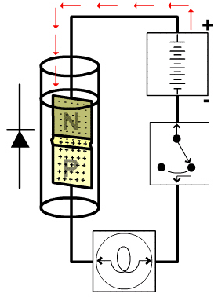
- Prevents current flow across the P-N junction during circuit operation
- Cathode connected to positive side of circuit
- Anode connected to negative side of circuit

